1. **INTRODUCTION**

We live in a time unlike any other. With so many technological advancements at our fingertips, our lives are made easier, which is fortunate considering the fast-paced lives most of us lead. In recent years, great strides have been made in making homes a bit more “tech savvy.” This technology, in short, allows the homeowner to run his or her home while away through a remote, often on a Smartphone or iPad. In fact, these homes have been labeled as being “smart,” due to the fact that they can seemingly think on their own. This ability to “think,” also known as being an automated home, helps homeowners in a number of ways.

**The use of automatic system is that it does not need manual operation for switching ON and OFF. When a person is entering into the room, the light automatically switches ON. When there is no one in the room the light goes off automatically**. The range of the sensor can also be adjusted by IR sensors. In our project we have 3 IR sensors for detection purpose, 2 bulbs each for one room , arduino board. We programmed the board according to the need.

* 1. **Objective of words**

The two main components used in this project are

1. Arduino
2. IR sensors

**What is an Arduino?**

[≡ Pages](https://learn.sparkfun.com/tutorials/what-is-an-arduino)

[Arduino](http://arduino.cc/) is an open-source platform used for building electronics projects. Arduino consists of both a physical programmable circuit board (often referred to as a [microcontroller](http://en.wikipedia.org/wiki/Microcontroller)) and a piece of [software](http://arduino.cc/en/Main/Software), or IDE (Integrated Development Environment) that runs on your computer, used to write and upload computer code to the physical board.

The Arduino platform has become quite popular with people just starting out with electronics, and for good reason. Unlike most previous programmable circuit boards, the Arduino does not need a separate piece of hardware (called a programmer) in order to load new code onto the board – you can simply use a USB cable. Additionally, the Arduino IDE uses a simplified version of C++, making it easier to learn to program. Finally, Arduino provides a standard form factor that breaks out the functions of the micro-controller into a more accessible package.

[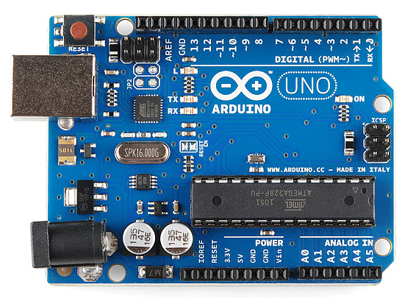](https://cdn.sparkfun.com/assets/9/1/e/4/8/515b4656ce395f8a38000000.png)

***Fig 1.1.1*** *:This is an Arduino Uno*

The Uno is one of the more popular boards in the Arduino family and a great choice for beginners.

**What Does it Do?**

The Arduino hardware and software was designed for artists, designers, hobbyists, hackers, newbies, and anyone interested in creating interactive objects or environments. Arduino can interact with buttons, LEDs, motors, speakers, GPS units, cameras, the internet, and even your smart-phone or your TV! This flexibility combined with the fact that the Arduino software is free, the hardware boards are pretty cheap, and both the software and hardware are easy to learn has led to a large community of users who have contributed code and released instructions for a **huge** variety of Arduino-based projects.

For everything from [robots](https://learn.sparkfun.com/tutorials/building-the-hub-ee-buggy) and a [heating pad hand warming blanket](https://learn.sparkfun.com/tutorials/heating-pad-hand-warmer-blanket) to [honest fortune-telling machines](https://learn.sparkfun.com/tutorials/the-uncertain-7-cube), and even a [Dungeons and Dragons dice-throwing gauntlet](http://www.sparkfun.com/tutorials/333), the Arduino can be used as the brains behind almost any electronics project.

**What's on the board?**

There are many varieties of Arduino boards that can be used for different purposes. Some boards look a bit different from the one below, but most Arduinos have the majority of these components in common:

[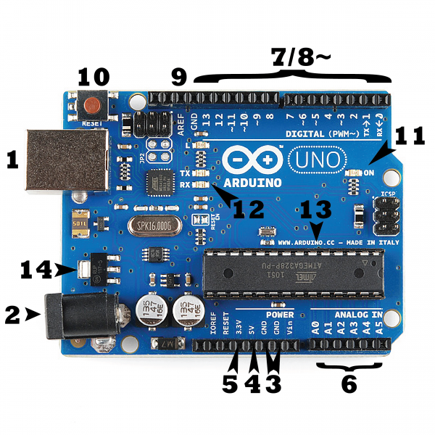](https://cdn.sparkfun.com/assets/b/f/e/9/c/513824face395f6d3d000000.png)

***Fig 1.1.2***

**Power (USB / Barrel Jack)**

Every Arduino board needs a way to be connected to a power source. The Arduino UNO can be powered from a USB cable coming from your computer or a wall power supply ([like this](https://www.sparkfun.com/products/8269)) that is terminated in a barrel jack. In the picture above the USB connection is labeled **(1)** and the barrel jack is labeled **(2)**.

The USB connection is also how you will load code onto your Arduino board.

**NOTE:** Do NOT use a power supply greater than 20 Volts as you will overpower (and thereby destroy) your Arduino. The recommended voltage for most Arduino models is between 6 and 12 Volts.

Pins (5V, 3.3V, GND, Analog, Digital, PWM, AREF)

The pins on your Arduino are the places where you connect wires to construct a circuit (probably in conjuction with a [breadboard](https://learn.sparkfun.com/tutorials/how-to-use-a-breadboard/) and some [wire](https://learn.sparkfun.com/tutorials/working-with-wire). They usually have black plastic ‘headers’ that allow you to just plug a wire right into the board. The Arduino has several different kinds of pins, each of which is labeled on the board and used for different functions.

* **GND (3)**: Short for ‘Ground’. There are several GND pins on the Arduino, any of which can be used to ground your circuit.
* **5V (4) & 3.3V (5)**: As you might guess, the 5V pin supplies 5 volts of power, and the 3.3V pin supplies 3.3 volts of power. Most of the simple components used with the Arduino run happily off of 5 or 3.3 volts.
* **Analog (6)**: The area of pins under the ‘Analog In’ label (A0 through A5 on the UNO) are Analog In pins. These pins can read the signal from an analog sensor (like a [temperature sensor](https://www.sparkfun.com/products/10988)) and convert it into a digital value that we can read.
* **Digital (7)**: Across from the analog pins are the digital pins (0 through 13 on the UNO). These pins can be used for both digital input (like telling if a button is pushed) and digital output (like powering an LED).
* **PWM (8)**: You may have noticed the tilde (~) next to some of the digital pins (3, 5, 6, 9, 10, and 11 on the UNO). These pins act as normal digital pins, but can also be used for something called Pulse-Width Modulation (PWM). We have [a tutorial on PWM](https://learn.sparkfun.com/tutorials/pulse-width-modulation), but for now, think of these pins as being able to simulate analog output (like fading an LED in and out).
* **AREF (9)**: Stands for Analog Reference. Most of the time you can leave this pin alone. It is sometimes used to set an external reference voltage (between 0 and 5 Volts) as the upper limit for the analog input pins.

**Reset Button**

Just like the original Nintendo, the Arduino has a reset button **(10)**. Pushing it will temporarily connect the reset pin to ground and restart any code that is loaded on the Arduino. This can be very useful if your code doesn’t repeat, but you want to test it multiple times. Unlike the original Nintendo however, blowing on the Arduino doesn’t usually fix any problems.

**Power LED Indicator**

Just beneath and to the right of the word “UNO” on your circuit board, there’s a tiny LED next to the word ‘ON’ **(11)**. This LED should light up whenever you plug your Arduino into a power source. If this light doesn’t turn on, there’s a good chance something is wrong. Time to re-check your circuit!

**TX RX LEDs**

TX is short for transmit, RX is short for receive. These markings appear quite a bit in electronics to indicate the pins responsible for [serial communication](https://learn.sparkfun.com/tutorials/serial-communication). In our case, there are two places on the Arduino UNO where TX and RX appear – once by digital pins 0 and 1, and a second time next to the TX and RX indicator LEDs **(12)**. These LEDs will give us some nice visual indications whenever our Arduino is receiving or transmitting data (like when we’re loading a new program onto the board).

**Main IC**

The black thing with all the metal legs is an IC, or Integrated Circuit **(13)**. Think of it as the brains of our Arduino. The main IC on the Arduino is slightly different from board type to board type, but is usually from the ATmega line of IC’s from the ATMEL company. This can be important, as you may need to know the IC type (along with your board type) before loading up a new program from the Arduino software. This information can usually be found in writing on the top side of the IC. If you want to know more about the difference between various IC’s, reading the datasheets is often a good idea.

**Voltage Regulator**

The voltage regulator **(14)** is not actually something you can (or should) interact with on the Arduino. But it is potentially useful to know that it is there and what it’s for. The voltage regulator does exactly what it says – it controls the amount of voltage that is let into the Arduino board. Think of it as a kind of gatekeeper; it will turn away an extra voltage that might harm the circuit. Of course, it has its limits, so don’t hook up your Arduino to anything greater than 20 volts.

**The Arduino Family**

Arduino makes several different boards, each with different capabilities. In addition, part of being open source hardware means that others can modify and produce derivatives of Arduino boards that provide even more form factors and functionality. Here are a few options that are well-suited to someone new to the world of Arduino:

[Arduino Uno (R3)](https://www.sparkfun.com/products/11021)

The Uno is a great choice for your first Arduino. It’s got everything you need to get started, and nothing you don’t. It has 14 digital input/output pins (of which 6 can be used as PWM outputs), 6 analog inputs, a USB connection, a power jack, a reset button and more. It contains everything needed to support the microcontroller; simply connect it to a computer with a USB cable or power it with a AC-to-DC adapter or battery to get started.

[](https://cdn.sparkfun.com/assets/9/1/e/4/8/515b4656ce395f8a38000000.png)

***Fig 1.1.3:***

**Lilly pad arduino**

This is LilyPad Arduino main board! LilyPad is a wearable e-textile technology developed by [Leah Buechley](http://web.media.mit.edu/~leah/) and cooperatively designed by Leah and SparkFun. Each LilyPad was creatively designed with large connecting pads and a flat back to allow them to be [sewn into clothing](https://learn.sparkfun.com/tutorials/sewing-with-conductive-thread) with conductive thread. The LilyPad also has its own family of input, output, power, and sensor boards that are also built specifically for e-textiles. They’re even washable!

[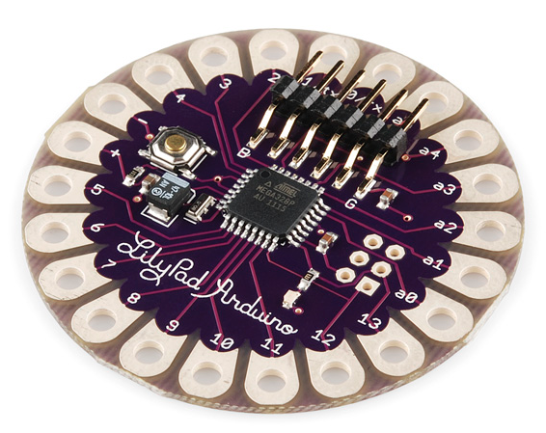](https://cdn.sparkfun.com/assets/3/b/6/2/6/515b5139ce395f314e000000.png)

***Fig 1.1.4 :***

[**RedBoard**](https://www.sparkfun.com/products/11575)

The RedBoard can be programmed over a USB Mini-B cable using the Arduino IDE. It’ll work on Windows 8 without having to change your security settings (we used signed drivers, unlike the UNO). It’s more stable due to the USB/FTDI chip we used, plus it’s completely flat on the back, making it easier to embed in your projects. Just plug in the board, select “Arduino UNO” from the board menu and you’re ready to upload code. You can power the RedBoard over USB or through the barrel jack. The on-board power regulator can handle anything from 7 to 15VDC.

[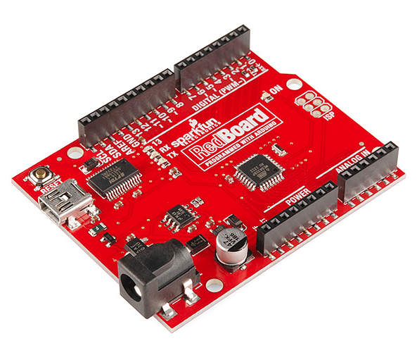](https://cdn.sparkfun.com/assets/0/9/4/7/3/515b53d7ce395fc351000000.png)

***Fig 1.1.5***

[**Arduino Mega (R3)**](https://www.sparkfun.com/products/11061)

The Arduino Mega is like the UNO’s big brother. It has lots (*54!*) of digital input/output pins (14 can be used as PWM outputs), 16 analog inputs, a USB connection, a power jack, and a reset button. It contains everything needed to support the microcontroller; simply connect it to a computer with a USB cable or power it with a AC-to-DC adapter or battery to get started. The large number of pins make this board very handy for projects that require a bunch of digital inputs or outputs (like lots of LEDs or buttons).

[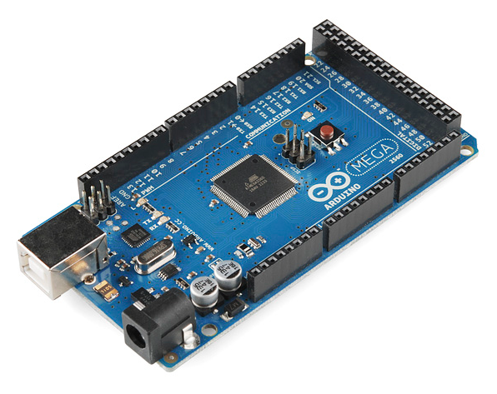](https://cdn.sparkfun.com/assets/9/2/3/f/f/515b547fce395f853c000007.png)

***Fig 1.1.6***

[**Arduino Leonardo**](https://www.sparkfun.com/products/11286)

The Leonardo is Arduino’s first development board to use one microcontroller with built-in USB. This means that it can be cheaper and simpler. Also, because the board is handling USB directly, code libraries are available which allow the board to emulate a computer keyboard, mouse, and more!

[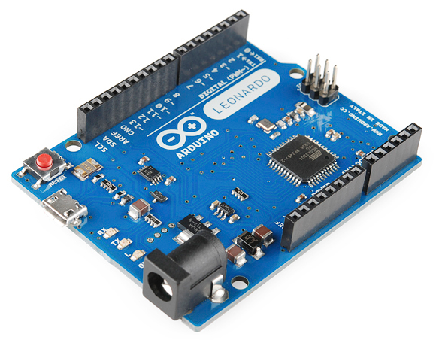](https://cdn.sparkfun.com/assets/3/2/0/f/1/515b5745ce395fc83c000001.png)

***Fig 1.1.7***

**The Extended Family**

While your Arduino board sure is pretty, it can’t do a whole lot on its own – you’ve got to hook it up to something. There are lots of tutorials here on learn as well as the links back in the ‘What does it do’ section, but rarely do we talk about the general *kinds* of things you can easily hook into. In this section we’ll introduce basic **sensors** as well as Arduino **shields**, two of the most handy tools to use in bringing your projects to life.

**2.Sensors**

**What is sensor?**

It is defined as an element which produces signal relating to the quantity being measured . According to the Instrument Society of America, sensor can be defined as “A device which provides a usable output in response to a specified measurand.” Here, the output is usually an ‘electrical quantity’ and measurand is a ‘physical quantity, property or condition which is to be measured’. Thus in the case of, say, a variable inductance displacement element, the quantity being measured is displacement and the sensor transforms an input of displacement into a change in inductance.

With some simple code, the Arduino can control and interact with a wide variety of **sensors** - things that can measure [light](https://www.sparkfun.com/products/9088), [temperature](https://www.sparkfun.com/products/10988), [degree of flex](https://www.sparkfun.com/products/8606), [pressure](https://www.sparkfun.com/products/11207), [proximity](https://www.sparkfun.com/products/242), [acceleration](https://www.sparkfun.com/products/9836), [carbon monoxide](https://www.sparkfun.com/products/9403), [radioactivity](https://www.sparkfun.com/products/11345), [humidity](https://www.sparkfun.com/products/9569), [barometric pressure](https://www.sparkfun.com/products/9721), [you name it](https://www.sparkfun.com/products/11574), [you can sense it](https://www.sparkfun.com/products/9964)!

[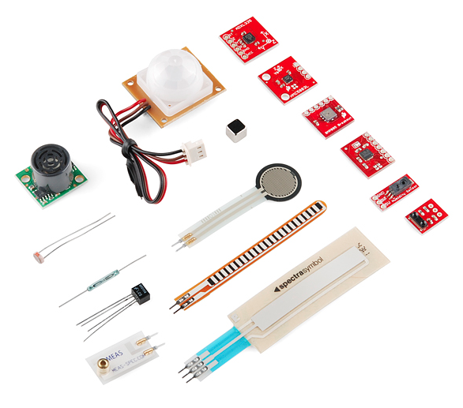](https://cdn.sparkfun.com/assets/c/7/b/e/a/515b587fce395fec38000001.png)

***Fig 1.1.8***

*Just a few of the sensors that are easily compatible with Arduino*

**Proximity sensors**

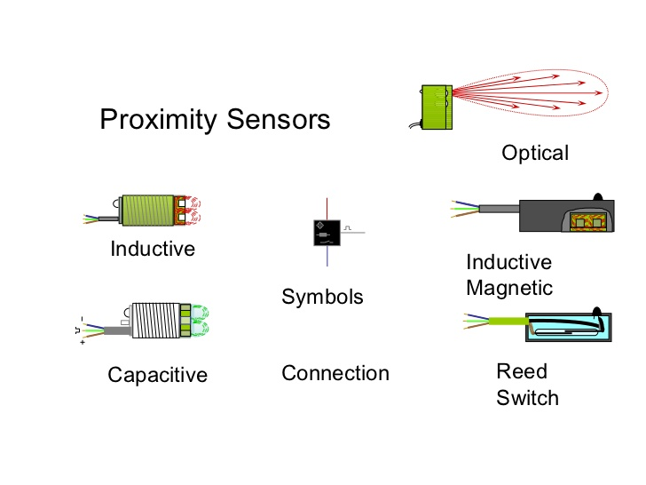

**Fig : 1.1.9**

**Proximity IR sensors:**

An infrared sensor is an electronic device , that emits in order to sense some aspects of the surroundings. An IR sensor can measure the heat of an object as well as detects the motion. These types of sensors measures only infrared radiation, rather than emitting it that is called as a passive IR sensor. Usually in the infrared spectrum, all the objects radiate some form of thermal radiations. These types of radiations are  invisible to our eyes, that can be detected by an infrared sensor. The emitter is simply an IR LED and the detector is simply an IR photodiode which is sensitive to IR light of the same wavelength as that emitted by the IR LED. When IR light falls on the photodiode, The resistances and these output voltages, change in proportion to the magnitude of the IR light received.

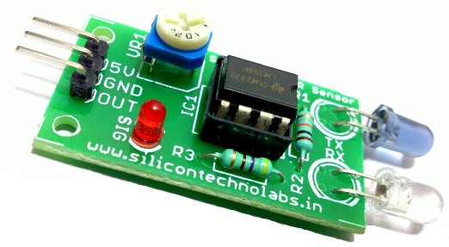

**Fig: 1.1.10**

1. **PROPOSED SYSTEM**

Automation, Power consumption and Cost Effectiveness are the important considerations in the present field of electronics and electrical related technologies. Industry of street lighting systems are growing rapidly and going to complex with rapid growth of industry and cities. To control and maintain complex street lighting system more economically, various street light control systems are developed.

These systems are developed to control and reduce energy consumption of a town's public lighting system using different technologies. The Proposed work is to control switching of street light automatically according to light intensity to develop flow based dynamic control statistics using infrared detection technology and maintain wireless communication among lamppost and control terminal using ZigBee Wireless protocol. This proposed system utilizes the latest technology for the sources of light as LED Lamps instead of generally used street lamps such as High Pressure Sodium Lamps, etc.

The LED technology is preferred as it offers several advantages over other traditional technologies like energy saving due to high current luminous efficiency, low maintenance cost, high colour rendering index, rapid start up speed, long working life etc.

This proposed system makes use of infrared photoelectric sensor (G12- 3C3PA) for person detection.

**2.1 BLOCK DIAGRAM**

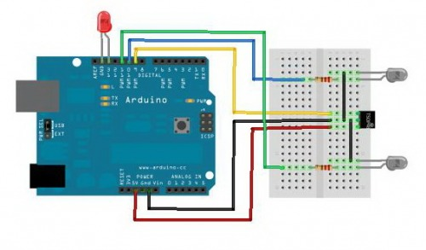

**Fig : 2.1.1**

**2.2 CIRCUIT DIAGRAM**

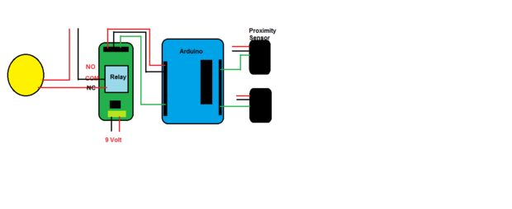 **Fig : 2.1.2**

* 1. **COMPONENTS USED**

1. Arduino

2. Proximity IR sensors

3. Bulbs

4. Bread board

5. Batteries (9V)

6. Jumper wires

**3. PROGRAMMING AND**

**EXECUTION**

### 3.1 Calibrating the Proximity Sensor

After interfacing the proximity sensor with Arduino board upload the callibrate program.

Determine the threshold at which the arduino must switch on the light

The serial monitor will show the reading Front for the proximity sensor of the front side of the door and the back will show the reading of the proximity sensor of the backside of the door.

**3.2 Explanation:**

Initially there are no persons in the house so no light in the house are ON. When a person is arriving to the house, the sensor in front of the door detects thee person and intimates the second sensor. When he opens the door then the both sensors will detect , then lights in the first room will be ON. Until he stays in that room the light will be ON. When the door of succeeding room opened both the second and third sensor will be in ON state. As soon as he enters the second room the second sensor gets deactivated and the third sensor will be in ON state and the bulb glows until he is in second room .

If two persons are in two rooms both sensors get activated and bulbs in two rooms will be ON. When two person leaves the house no one is detected by the sensors, automatically bulbs will be off .

**3.3 PROGRAM:**

void setup()

{

pinMode(5,INPUT);

pinMode(3,INPUT);

pinMode(9,INPUT);

pinMode(7,OUTPUT);

pinMode(2,OUTPUT);

}

void loop() {

int x1=digitalRead(5);

int x2=digitalRead(3);

int x3=digitalRead(9);

if(x1==0&&x2==0)

{

digitalWrite(2,HIGH);

}

if(x1==1&&x2==0)

{

digitalWrite(2,HIGH);

}

if(x1==0&&x2==1)

{

digitalWrite(2,LOW);

}

if(x1==1&&x2==1)

{

digitalWrite(2,LOW);

}

if(x2==0&&x3==0)

{

digitalWrite(7,HIGH);

}

if(x2==1&&x3==0)

{

digitalWrite(7,HIGH)

}

if(x2==0&&x3==1)

{

digitalWrite(7,LOW);

}

if(x2==1&&x3==1)

{

digitalWrite(7,LOW);

}

}

**4. RESULT:**

**Pics:**

This is how automatic switching ON and OFF of light in the house can be controlled and used

**4.1 ADVANTAGES**

1. Conserve electricity: low electricity

consumed

2. No manual work is required

3. Speed- greater speed of ON and OFF of the light

4. safety: from electrical shocks.

**5. CONCLUSION**

Lights are a large consumer of energy for cities using up to 50 percent of a city's energy budget. If every city installs the proposed system then a lot of power can be saved .Proposed system is power saving mechanism for lights by using LED lamps as replacement of normal lamps and using special power savings mechanism for microcontroller rand ZigBee modules. It turns out most reliable and time efficient way to switch ON/OFF lights. It provides an effective measure to save energy by preventing unnecessary wastage of electricity, caused due to manual switching or lighting of lights when it is not required. The proposed system is especially appropriate for house lighting and also for street lighting in remote urban and rural areas where the traffic is low at times. The system is versatile, extendable and totally adjustable to user needs.

**6. REFERENCES**

**[1] Energy Efficient Lighting Control System Design For Corridor illumination, Jayashri A.Bangali, Arvind D.Shaligram International Journal of Scientific & Engineering Research Volume 3, Issue 4, April-2012 ,ISSN 2229-5518.**

**[2]** [**www.instructables.com**](http://www.instructables.com)

**[3] E4U magazine**